The Math of Minecraft Challenge
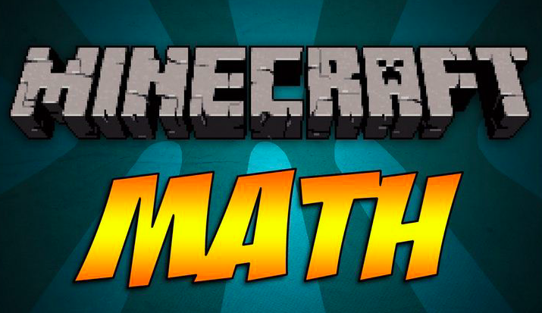

Cross-Curricular History & Math Collaborative Project
After your study of the rise and decline of feudalism in western Europe, students will complete the mathematical calculations included below in order to connect numbers to historical importance via Minecraft. Be precise, and may the best mathematician win.

California Common Core Standards
7.7 RP Analyze proportional relationships and use them to solve real-world and mathematical problems.
7.7.RP.2 Recognize and represent proportional relationships between quantities.
7.7 G Draw, construct, and describe geometrical figures and describe the relationships between them.
7.7 SP Use random sampling to draw inferences about a population.

Instructions
Students will complete the following mathematical calculations based on the statistics provided for specific structures from Medieval Europe: peasant houses, a mill, a manor house, and a church. Refer to the structures labeled in the Math of Minecraft iMovie link. All students must use information contained in the iMovie for their work.

Step 1 - Total Blocks of Key Structures (Based on stats from the Math of Minecraft iMovie link)
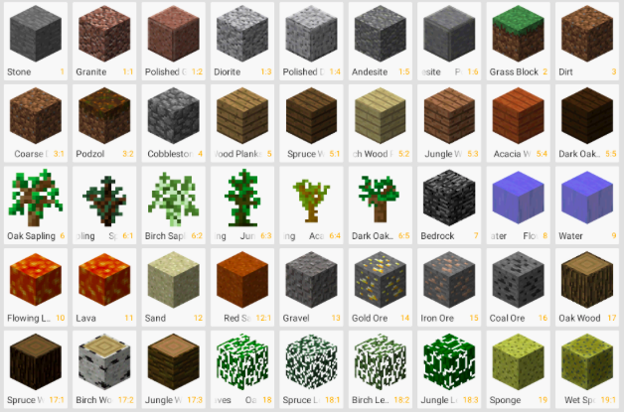
Part I
Based on the number of blocks needed to complete the four main structures in the Medieval Manor build, record the Total Blocks of each distinct structure from the sample builds.

Medieval Manor #1
Total Blocks of Peasant House -
Total Blocks of the Mill -
Total Blocks of the Manor House -
Total Blocks of the Church -
Total Overall Blocks -

Medieval Manor #2
Total Blocks of Peasant House -
Total Blocks of the Mill -
Total Blocks of the Manor House -
Total Blocks of the Church -
Total Overall Blocks -

Medieval Manor #3
Total Blocks of Peasant House -
Total Blocks of the Mill -
Total Blocks of the Manor House -
Total Blocks of the Church -
Total Overall Blocks -

Part II - Math Extension Activity
Based on Total Blocks used for each key structure of the three sample Medieval Manors in the iMovie, add the blocks for each structure to find the total number of blocks. After you have completed this step, calculate what percent of the total blocks that each structure represents. Include this information below.

Medieval Manor #1
Percent of Total Blocks - Peasant House -
Percent of Total Blocks - Mill -
Percent of Total Blocks - Manor House -
Percent of Total Blocks - Church -

Medieval Manor #2
Percent of Total Blocks - Peasant House -
Percent of Total Blocks - Mill -
Percent of Total Blocks - Manor House -
Percent of Total Blocks - Church -

Medieval Manor #3
Percent of Total Blocks - Peasant House -
Percent of Total Blocks - Mill -
Percent of Total Blocks - Manor House -
Percent of Total Blocks - Church -
Part III Cross-Curricular Reflection
After completing the percentage calculations above, of the three Medieval Manor builds, in which build did the Manor House represent the highest overall percentage of the Total Blocks Used (There could be more than one)? Based on your study of Feudalism in the Middle Ages, is this percentage an accurate representation of how important this structure was in comparison to the other three structure during the Middle Ages? Justify your response with insight from your study of Feudalism. Respond in 50+ words.

Step 2 - Taxation in Feudalism (Situation 1 and 2 are NOT BASED on the Math of Minecraft iMovie link)
Based on each of the structures that you completed as part of your Medieval Manor Design to Survive Project, you will calculate which option will be least expensive based on the two taxes (tallage and head tax) that are required to be paid by different members of the feudal hierarchy in the situations below.

Situation #1 - Tallage
The Lord of the manor has placed a tallage tax on serfs and peasants for the amount of blocks they use to construct their peasant houses. He gives peasants the option of using their own money to pay him BEFORE the construction of the house, or to pay AFTER it is completed. If peasants choose to pay for their blocks BEFORE building their house, they pay a flat rate of 135 shillings per block. However, if peasants choose to get a loan from the Lord of the manor and pay AFTER they have constructed their house, they pay a rate of 125 shillings per blocks and then pay 22% interest on top of the total cost of the house.

Problem I
Based on these rates, use the info you gathered in Step 2 about Blocks used for Peasant Houses to determine whether it is cheaper for peasants to use their own money or to get a loan from the Lord of the manor. Explain your reasoning.

Problem II
Assume that the Lord has 16 peasant houses on his manor. 25% of the houses opt to pay their own money BEFORE building, and 75% opt to get a loan from the Lord AFTER completion. Based on these percentages, what is the total amount of shillings the Lord will collect from taxing his peasants? Explain.

Problem III
If the Lord plans on using the money from the tallage tax to purchase more land to cultivate crops, and he knows that a 10x10 patch of land cost 12 shillings and an 8x8 patch of land costs 9 shillings, determine which size of land is cheaper, and then calculate how many total patches of that sized land he can afford to buy. Explain.

Situation #2 - Head Tax
The king has decided to place a head tax on all individuals living on each manor within his kingdom. He has decreed that individuals will pay a flat rate based on their status within the feudal system. The king assumes the following ratio of individuals per structure: 4 individuals per peasant house, 7 individuals per mill, 15 individuals per manor house, and 34 individuals per church. Individuals dwelling in peasant houses and mills will pay 2.5 farthings per person, individuals in manor houses will pay 5.5 farthings per person, and individuals dwelling in churches will pay 8.5 farthings per person.

Problem I
If the king has 137 manors to tax, based on these rates, calculate how much total money the king will make off of the head tax for each manor. Explain your results.

Problem II
If 50 farthings = 1 shilling, calculate how many total shillings the king will actually make off of the head tax for each manor.

Problem III
If the king plans on using the money from the head tax to purchase armor for his most loyal knights, and a complete suit of armor costs 10 shillings, whereas a shield and sword only cost 2 shillings, how many complete suits of armor can the king purchase and how many shield/sword combinations can he purchase? Explain your results.

Success!
When you have completed the Math of Minecraft Challenge, submit your work to...

